Environmentalism in India

**Report of the workshop Environmentalism in India: Building Perspectives and Sharing Strategies**

**28th September to 3rd October, 2013**

[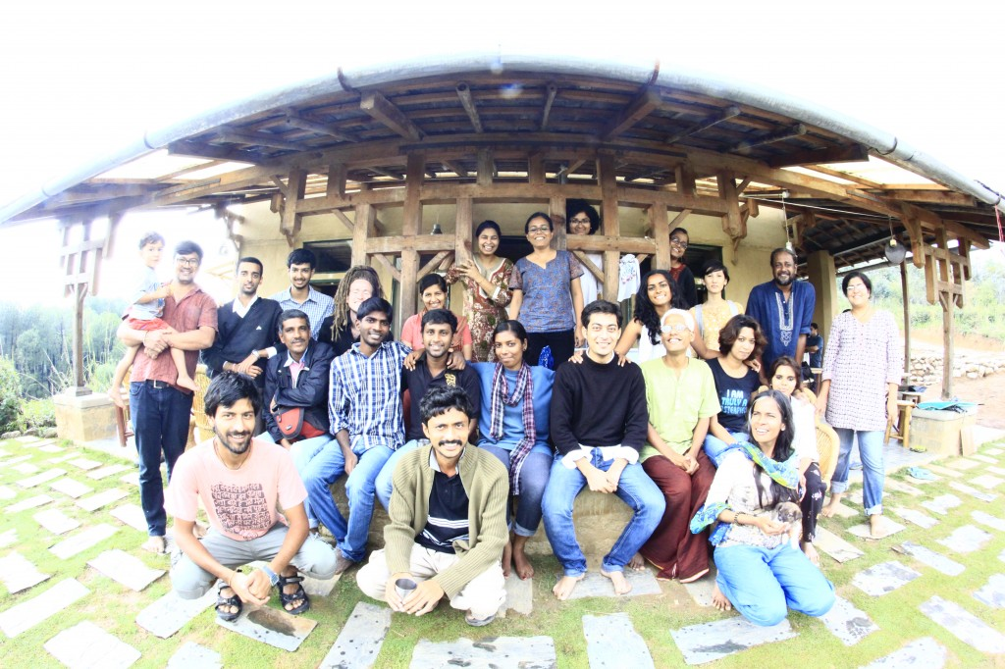](http://www.sambhaavnaa.org/wp-content/uploads/2013/08/Group-Photograph.jpg)

**1. Concept**

Increasingly, environmental problems and their so-called solutions are disproportionately hurting the poor. From forest conservation to city beautification, from extractive industries to the glitzy IT sector, “development” has meant bad news for India’s poor and those dependent on natural resources for a living. Simultaneously, mindless industrialisation, and pollution and exploitation of resources like land and water is having a telling effect on the health of people, and will have lasting implications for generations to come.

As if this pattern of development has not already caused enough damage, India is on course to accelerate this development. This will manifest itself as more power plants, coal mines, Environmentalism in India.

Increasingly, environmental problems and their so-called solutions are disproportionately hurting the poor. From forest conservation to city beautification, from extractive industries to the glitzy IT sector, “development” has meant bad news for India’s poor and those dependent on natural resources for a living. Simultaneously, mindless industrialization, and pollution and exploitation of resources like land and water is having a telling effect on the health of people, and will have lasting implications for generations to come.

As if this pattern of development has not already caused enough damage, India is on course to accelerate this development. This will manifest itself as more power plants, coal mines, dams, ports, highways, malls, mines, smelters, sprawling industrial complexes, IT companies, desalination plants, roads to places where roads were never meant to go. The infrastructure of survival for communities is being replaced by the infrastructure for big commerce. Add to this mixed bag of bad news, the uncertainties that will come with changing climate. Rising sea levels will inundate low-lying coastal lands. The newly homeless people, including predominantly fisher-folk, will join the ranks of climate refugees. Sea level rise will also bring with salinity intrusion into aquifers devastating farming livelihoods in prosperous and fertile delta and coastal areas. Extreme weather events, like the recent rainfall-induced landslides and flash floods, can be expected to increase in frequency and intensity. These two will affect the less resilient people – the poor and marginalized – more than anybody else.

India may be a country with a visibly unequal society riven by discrimination on the basis of caste, religion, and gender. But it is also a place populated with vibrant movements and struggles for environmental justice, where many communities and environmental activists have campaigned and lobbied for environmental justice through a gamut of initiatives – through public policy changes, the courts and the recently formed National Green Tribunal, or through direct public pressure. Many groups are working on reviving traditional systems of resource management and others on inspiring young people in urban and rural areas to work towards protection of the environment. What are the key issues they face and the strategies they use? What is the way forward for Environmental Justice in India? What are the key legislation that govern environmental justice and what has been the experience of environmentalists and others who have tried to access the environment justice system? What are the forces today that are shaping this system?

To address some of these questions, Sambhaavnaa Institute – in collaboration with Corporate Accountability Desk organised a one week capacity building workshop for young practitioners in the field of environment; be they lawyers or campaigners, grassroots activists or young researchers who are looking to enhance and sharpen their understanding of Environmental Justice issues in the country.

**RESOURCE PERSONS:**

**1. Amita Baviskar**  
Associate Professor of Sociology at the Institute of Economic Growth, Delhi, Her research interests are the cultural politics of environment and development, with a focus on social inequality and natural resource conflicts and environmental and indigenous social movements.

**2. Soumya Datta**  
Convenor of Bharat Jan Vigyan Jatha; researcher-activist who works on issues of climate change and environmental justice . He has recently co-authored the book, ‘Climate Change and India : Analysis of Political Economy and Impact’ .

**3. Nityanand Jayaraman**  
Writer, researcher and environmental activist based in Chennai. He specialises in investigating and reporting on the environmental and human rights track record of corporations. He is part of a voluntary collective called Corporate Accountability Desk

**4. Dunu Roy**  
Founder of Hazard Centre, a research group which is assisting urban and rural communities in research and action programs related to shelter, livelihoods, services, and governance and in the struggle for justice by the urban poor.

**5. Rahul Saxena and Manshi Asher**  
Researcher-activists who are part of an environmental research and action collective, Himdhara who work closely with communities struggling for their rights over natural resources.

**6. Balkrishna Sharma**  
Environmental activist who works on issues of Industrial pollution with Him Parivesh, Solan

**7. Karen Coelho**

Academic working at the Madras Institute of Development Studies in Chennai, specifically working on issues of Urbanisation and development

**2. Workshop Sessions**

**DAY 1 : 28thSeptember**

**Rahul Saxena and Bal Krishan Sharma**: *Toxic Tour Nalagarh*

Industrial Pollution and CEM: Interaction with Him Parivesh members

[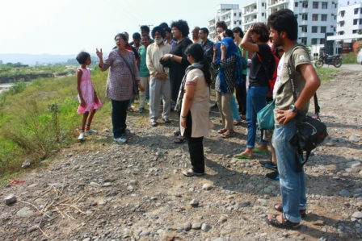](http://www.sambhaavnaa.org/wp-content/uploads/2013/08/Toxic-Tour.jpg)

**DAY2 : 29thSeptember**

**Nityanand Jayaraman**: Introduction to Environment and Development

Introduction to Thematic Groups among participants:

a) Socially  inclusive garbage management, and abolition of caste  
b) Worker Vs Environment – Coal mineworkers and Climate Change Tribal Upliftment and Mainstreaming Adivasis  
d) Are Sustainable Cities possible?  
e) Is sustainable development possible?

**Sandhya Gupta and Sarit Sharma**: *Tour of Sambhavnaa*  
Introduction to the ecologically friendly design, use of mud, bamboo and local building materials and the vision behind the place.

**Karen Coelho**: History of Development: Tracing the history and evolution of ‘development’ from the colonial era to the contemporary use of the term.

**Amita Baviskar**: History of Environmentalism: Tracing the history and evolution of environmentalism in the Indian context – from the pre-colonial to the contemporary.  Alienation of people from their natural environments and resources and the role of ‘development’ in the same.

**DAY 3 - 30thSeptember**

**Nityanand Jayaraman:** Reflections and discussion Media, Science and Democracy – Case Study: Koodankulam

**Dunu Roy:***Politics of Science*:

* Understanding Science and how it can be used to define the root causes of a problem instead of focusing on its solution.
* Understanding Frames and how they can be used by various bodies and people to  influence opinions and thought processes.

**Nityanand Jayaraman** **and** **Dunu Roy:**Case study Presentation/ Group exercise

**DAY4 : 1st October**

**Nityanand Jayaraman**:Reflections and discussion Draft Presentations by Thematic Groups

**Soumya Dutta**: *Climate Justice:*

* Understanding what constitutes climate change, recycling capacity of the Earth and how anything in excess of this recycling capacity affects the various aspects of Earth like atmosphere, species, sea temperature etc. with various examples
* How did Climate Change become an issue of governance with detailed discussions on Earth Summits, Kyoto Protocol and current international stand and negotiations on its implementation
* Understanding the concept of carbon [TRADING[http://cdncache-a.akamaihd.net/items/it/img/arrow-10x10.png](http://www.sambhaavnaa.org/environmentalism-in-india)](http://www.sambhaavnaa.org/environmentalism-in-india) and other international economics and politics of climate negotiations with focus on policies and stand by various Blocks like ALBA ,  AU, G77 and China and the US
* What is India’s stand on Climate Change and what is happening within the country to tackle the issue. Understanding the role of NAPCC and SAPCC and its various national and state missions.

**DAY 5 : 2nd October**

**Nityanand Jayaraman**:Draft Presentations by Groups + Feedback

Understanding and Researching Corporations; (Film “The Corporation” 1 hour)

**Nityanand Jayaraman :***Basics of Campaigning*:

A detailed analysis of the Campaign against Dow was shared which included how the Campaign evolved over the years, the involvement of media and what worked or did not work, the various innovations done which have kept the momentum alive, how people both nationally and internationally have participated to fuel the campaign and how the campaign has impacted government policies towards compensation, laws for safety standards and environmental impacts and [TRADE[http://cdncache-a.akamaihd.net/items/it/img/arrow-10x10.png](http://www.sambhaavnaa.org/environmentalism-in-india)](http://www.sambhaavnaa.org/environmentalism-in-india) relations with Dow.

*Right to Information:*

1. What is Right to Information and what kind of data can be sourced through this and from what agencies / bodies.
2. Understanding the whole process of RTI staring with an application, who to address, how many days it takes to receive a reply etc
3. What are the various types of information that cannot be shared
4. An exercise on writing an RTI application with special focus on the semantics and usage of words / language and how to form a question so as to get the expected reply
5. What is the process to be undertaken in case the applicant does not receive a reply

**Rahul Saxena:***Tools for Advocacy Contd.: Legal Advocacy:*

A detailed case study of a Bajoli Holi Hydropower Project in Chamba which is currently being in the process of construction on the Ravi river basin by GMR and how various types of violations (by both GMR and the state government) have taken place in order to get the project off ground . Details included understanding of the various processes pre, during and post construction of a hydro power project, the various laws, the various stages of approval and how state judicial system reacted to the entire case.

**Manshi Asher:***Mass Mobilisations: Case Study of Posco*:

A detailed analysis of the ongoing movement against POSCO was also shared which included the history behind the project and how it affected the communities involved, various socio-political angles with special emphasis on movement leadership, the involvement of the communities specially that of children and women in the movement, violence as a tool of repression by the state and various forms of agitation / resistance successfully adopted by the communities.

**DAY 6 : 3rd October**

**Rahul Saxena, Bhargavi and Manshi:** *Presentations by Groups*: Participants of 5 groups present their issues through drama, song and skits

**Ira, Sandhya, Manshi and Bhargavi:***Last session:  Over-all Feedback*

**3. Feedback and Over-all observations**

-        The field trip component was something new that was tried as a part of this workshop and there were many logistical difficulties in organising the same, especially getting all the participants to reach the meeting point – Chandigarh – on time. Further, the trip seemed a bit hurried and it felt like we could have spent more time on this. The toxic tour, as the trip was called, was mainly to highlight the issue of industrial pollution in the Industrial towonship of Baddi-Barotiwala-Nalagrh and the interventions by Him Parivesh, a local group of senior citizens who have been working on this issue. The feed back from the participants indicated that this was an important component of the entire program and infact should be extended to two days – with some more intensive sessions. Perhaps, the field component could include a 2 day trip in and around Delhi. This needs to be further explored

-        The sessions were designed mainly to stir up discussions and reflections on concepts as well as perspectives rather than provide solutions. The sessions on ‘Tools for Advocacy’ was spread over a day. This session could have been done over 2 days as well, was the overall feedback from the group. We felt that we could not discuss much on alternatives and that a separate session should be designed on this. This would mean making this a week long program.

-        The session that introduced the History of Environmentalism – introducing concepts of development and the systemic issues around environment in India – needed more time as well is what the resource person and organisers felt. But the participants in their feedback felt that the sessions were adequate and that more classroom conversation would be too over-whelming

-        All the sessions were well received but it was felt that the session on Climate Justice was too over-whelming with a lot of information – How could this be made more interactive and also designed in a way that there are breaks for participants to digest the information

-        Resource Material was circulated by all Resource Persons but participants felt that this should be provided a month in advance and some reading should be pre-requisite to avoid the sessions from becoming over-whelming

-        While we had a film screening as part of the workshop, some participants felt that the AV component should be given more time and more documentary films should be screened. Others felt that the time could be used for interactive exercises like community labour or community kitchen. Some others felt that documentary film screenings should be made optional in the evening

-        Participants felt that there should be a session on ‘individual actions and initiatives towards lifestyle changes for ecological sustainability’.

-        The diversity of the background of participants was appreciated by the entire group and it seemed that the length of the program and the location provided a good opportunity for building rapport amongst the participants.

**4. Participants:**

|  |  |
| --- | --- |
| **Name** | **Orgnization Name** |
| ManojMatwal | Halera (Hnads Applying reconciliation ecology through local aechetype) |
| EshwarPrasad | PARISARA – Environment Protection Organisation |
| Bipasha Majumdar | Individual |
| Bilalkhan | NationalAlianceofPeople’sMovements(NAPM) |
| Ruchika | HazardCenter |
| ChitraUpadhyay | FilmMaker |
| G.L.Janardhan | Environment |
| Panshul | Individual |
| D.RajaRao | Diksha |
| SteffenRohkohi | InternatRosaLuxemburgStiftungSouthAsia |
| StellaJames | NaturalJustice-LawyersforCommunities&Environment |
| LillanSum | SacredEarthTrust |
| PriyaPrabhakaran | Student,Bhoomicollege |
| A.Vasudha | HazardCenter |
| MukundRamesh | Envirocentre |
| Kesang | Student,DelhiSchoolofEconomics-Delhi |
| RoyJacob | Sahayatra |
| Veronica | Student,MadrasSchoolofSocialWork |
| oeMeshache | Student,MadrasSchoolofSocialWork |
| NiveditaElengo | Student,MadrasSchoolofSocialWork |
| Geeta | AntGMCoalitongroup |
| SushreeBijetaMohenty | Advocate |